Minutes of the ALLEGRO 9th Project Coordination Team meeting

June 25-26, 2018

Budapest
Danubius Hotel Flamenco
Tas vezér utca 3-7, H-1113 Budapest, Hungary
Version 0
The meeting was attended by:
A. Vasile, D. Gallo (CEA, France),
L. Bělovský, P. Vácha, M. Gren, (ÚJV Řež, a. s., Czech Republic),
G. Mayer, Z. Hozer (MTA-EK, Hungary),
P. Ponya, (BME-NTI, Hungary)
J. Malesa, (NCBJ, Poland),
B. Hatala, P. Dařílek, S. Bebjak, B. Kvizda, M. Cvan (VUJE, a.s., Slovak Republic)
O. Frýbort (Centrum výzkumu s.r.o., Czech republic)
P. Sarkadi (GRS, Germany)

Agenda
 | June 25, 2018, Monday
10:00 | Welcome | B. Hatala
10:10 | Approval of the Agenda | ALL
10:15 | Review of actions | All
10:30 | Status of ALLEGRO reference document  ALLEGRO Design Specification | Belovsky
11:00 | Status of ALLEGRO reference document  ALLEGRO V4G4 Concept Database | Kvizda
 | Status of ALLEGRO reference document  ALLEGRO R&D Roadmap | Belovsky
11:20 | Coffee break
11:40 | Current status of S-ALLEGRO loop | Frybort
12:00 | Decay heat removal using supercritical CO2  Is it feasible?  (result of project HERO) | Frybort
12:30 | Lunch
13:45 | Proposal of additional scram system for ALLEGRO core | Darilek
14:10 | ALFA2 project proposal | Hatala
15:00 | Coffee break
15:20 | Discussion to the proposed ALFA2 project
16:00 | End of the first day
 | June 26, 2018, Tuesday
9:00 | Welcome
9:05 | Summary of meeting IAEA Coordinated Research Project  Benchmark Analysis on Physics Start-Up Experiments of China Experimental Fast Reactor (CEFR)  (Meeting 11-14 June 2018, Vienna)  SERPENT Validation | Dařílek/Ponya
9:45 | Review of I&C setpoints and decay heat strategy | Mayer
10:15 | Information of CATHARE2 input deck update by NCBJ and results of LOCA and SBO. | Malesa
10:30 | Coffee break
10:50 | Short-term workplan for the ALLEGRO | ALL
 | Hungarian national program | Mayer
 | Results of Czech national project CANUT - severe accidents and core coolability | Vacha
 | Recently accepted Czech research and development projects | Vacha
12:30 | Lunch
13:30 | Status of ALLEGRO website | ALL
 | Feedback from GIF activities | Hatala/Vasile
15:00 | Coffee break
15:15 | Summary of the new actions
 | Preparation of the presentation to the Steering Committee
 | Wrap up and discussions, next meeting
16:30 | End of the meeting

The meeting was opened and chaired by B. Hatala. After welcome speech the agenda was approved.
The ALLGERO reference documents have been reviewed with the following result:
ALLEGRO Design Specifications (edited by UJV)
- The Design Specifications (i.e. the basis of design) of individual systems, structures and components (SSCs) shall be formulated best by specialists sufficiently understanding the given topic.
- Designers of the SSCs can start the corresponding design work only after having at least the minimum set of design specifications in hand. To this moment unknown, values, properties and requirements to these SSCs shall be at least qualitatively listed and marked e.g. TBD (to be determined).
- Although the responsibility for the individual chapters can be deduced from the Design & Safety Roadmap, L. Bělovský.will distribute a revision containing this information (in the name of each chapter). The already distributed Rev.4 contains example of the design specifications formulated by UJV for the He recovery & Primary He purification systems.
- V4G4 partners are kindly asked to formulate the Design Specifications (under their responsibility) for the most important SSCs as soon as possible.
ALLEGRO R&D Roadmap (edited by UJV)
- The R&D Roadmap is tightly bound with both the Design Specifications & the Design & Safety Roadmap. It indicates areas, where analytical & experimental support is needed to support the Design & Safety work on ALLEGRO V4G4. The current version of the R&D Roadmap represents at this moment a ready-to-use list of items/chapters analogous to those in the Design specifications and the Design & Safety Roadmap aimed at formulating the needed R&D (if any !).
- A separate chapter will be added by L. Bělovský with the aim to generally formulate the R&D needed in the most important areas (safety, thermohydraulics, fuel, materials, components, …). This version will be distributed to the partners before the end of 09/2018 to be commented and revised by partners.
ALLEGRO V4G4 Concept Database
- B. Kvizda presented the revision 0 of this document which summarizes the current knowledge of all systems of ALLEGRO reactor. The document is extended document from VINCO benchmark database. Some chapters of this document are still empty due to missing data.
- A. Vasile proposed to add one general chapter (or subchapters to every system) regarding thermal insulations. The document will be uploaded on the ALLEGRO website.
- L. Bělovský asked VUJE to freeze the currently available database of the ALLEGRO CEA 2009 concept with the aim to document the status of ALLEGRO at the beginning of the design & safety work targeted to develop ALLEGRO V4G4. L. Bělovský is willing to prepare this frozen version as soon as he receives the current version of the Database.
O. Frybort (CVR) informed about news and updates of S-ALLEGRO loop and about planned commissioning tests (1Q/2019). The coaxial valves are ready for installation. CV Řež prepared the draft of S-ALLEGRO database. This document is still in progress. It contains basic specification of loop systems and components.
O. Frybort (CVR) informed about results of HERO project which is dedicated for decay heat removal from PWR reactor type using supercritical CO2 system. The possibility of using this system for ALLEGRO reactor for decay heat removal was discussed.
P. Dařílek (VUJE) presented the proposal of a diverse passive shutdown system. The idea is to let fall down several fuel subassemblies. The subassembly axial shielding (absorber) is moved to the active core and the fuel part of the subassembly is moved outside the active core (similar to the VVER concept). The diverse passive shutdown system is crucial in order to eliminate unprotected transients. The neutronic calculations showed the neutronic efficiency of this system but the technical solution of it's implementation should be developed (e.g. based on Curie temperature). The presented sensitivity calculations showed that drop of two or three subassemblies is sufficient to reach subcriticality.
B. Kvizda (VUJE) presented comprehensive sensitivity analysis focusing on core cooling during whole spectra of the ALLEGRO steady states, defined by variation of system pressure (0.1 – 7MPa), core power (2.25 MW – 75 MW) and helium velocity (0 – 160 m/s). Results prove necessity to eliminate unprotected scenarios by developing extremely reliable passive reactor trip system (e.g. as proposed by P. Dařílek above).

The ALFA2 project proposal was discussed. The project refers to the Euratom Work Programme 2018 and addresses the topic “NFRP-2018-2: Model development and safety assessments for Generation IV reactors”.
Structure of the project:
WP1 - Project inception Phase ()
WP2 - Experimental program (CVR)
WP3 - Development, upgrade and validation of numerical tools ()
WP4 - Education and Training (STU)
WP5 - Integration and Dissemination of results (BME NTI)
WP6 - Project management and scientific coordination (VUJE)

P. Dařílek (VUJE) presented summary of the 1st Research Coordination Meeting of IAEA Coordinated Research Project, “Neutronics Benchmark of CERF Start-Up Tests”, organized in Vienna (11-14 June 2018). CEFR is Chinese experimental sodium fast reactor 65 MWth (20 MW_{el}) using highly enriched uranium fuel. The fuel loading, the first criticality experiments (at 20°C, 250 °C and 360 °C temp.) and experiments selected for the benchmark were presented. P. Ponya is the WP leader responsible for the collection of the Temperature reactivity coefficient data.
G. Mayer (MTA EK) presented review of the I&C setpoints and decay heat strategy of ALLEGRO. The sensitivity on the hot duct guillotine break was presented. It shows that starting the DHR contributes to higher peak cladding temperatures. Mayer proposed several solutions how to eliminate consequences: 1) Core power (power density) decreasing, 2) Varying enrichment as proposed by A. Keresztúri (large uncertainty), 3) Change of I&C (speed of main motors) and 4) Addition of 3rd main loop (not yet investigated). G. Mayer informed about the Hungarian national program as well.
J. Malesa (NCBJ) informed about progress of the ALLEGRO model development for CATHARE2 code. He has presented new results of the LOCA and SBO transients as defined in VINCO TH benchmark exercise. Besides that sensitivity calculations with ALLEGRO CATHARE2 model on the He-Water heat exchanger efficiency were presented.
P. Vácha (UJV) informed about Czech research and development projects funded by TAČR (technology agency of Czech Republic): ALLEGRO, NOVA (New Inorganic Materials), HEA (High Entropy Alloys), DUSIK (Degradation of materials in gases). TAČR supported also CANUT project related to ALLEGRO severe accidents and core coolability. The results of severe accident analysis (SBO + LOCA, guillotine LOCA, water ingress + SBO) and core coolability enhancement analyses (protected LOCA + SBO 1”, 3”, 10”) were presented.
Report and presentation to the SC on the progress in ALLEGRO development has been prepared with the contribution of all participants and finalized by A. Vasile.
The following table summarizes the next expected activities.
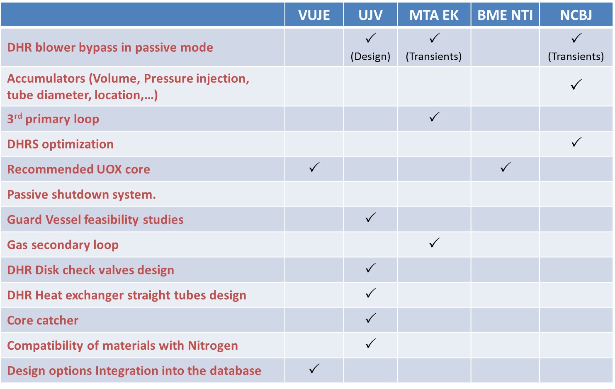

The next 10 PCT meeting will be held in Trnava on October 22-23, 2018.
The 27thSteering Committee will be held in Trnava on October 24, 2018

Status of actions of the ALLEGRO Project Coordination Team meetings
 | Action | Who | When | Status
PCT7.1 | Update of document “ALLEGRO Oxide Core Design Criteria” | Belovsky Dařílek, Vasile Gren | December 2017 | done
PCT7.2 | Fill up the table with neutronic data | Gren, Darilek | December 2017 | done
PCT7.3 | Static Thermo-aerolics numerical model | Bebjak | January 2018 | done
PCT7.4 | Selection of the core configuration
PCT7.5 | Reactivity worth in experimental positions of UOX, steel and MC (central and periphery position) | Ponya | Nomvember 2017 | done
PCT7.6 | Summary of transient calculations (RELAP5, CATHARE, MELCOR) | Mayer,  Vacha, Kvizda | January  2018
PCT8.1 | Upload the reference documents to ALLEGRO Server | Hatala | April 2018
PCT8.2 | “ALLEGRO V4G4 Concept Database“  Update | Kvizda | June 2018
PCT8.3 | Update of document  “Design specifications“ | Belovsky | April 2018
PCT8.4 | Development of document  ALLEGRO R&D roadmap  DRAFT 0 | Belovsky | June 2018
PCT8.5 | Update the table  „Promising UOX core configurations“ | Darilek | June 2018 | done
PCT8.6 | Update of CATHARE license | ALL | 2018
PCT8.7 | Review of I&C setpoints  and decay heat strategy | Mayer
PCT9.1 | Update of ALFA2 Project proposal distribute to partners for review | Hatala | July 2018
PCT9.2 | Update of document ALLEGRO Design Specification | Belovsky | September 2018
PCT9.3 | Update of document ALLEGRO R&D Roadmap | All | October 2018
PCT9.4 | Selection of the most promising UOX core configurations | Darilek + Ponya | October 2018
PCT9.5

